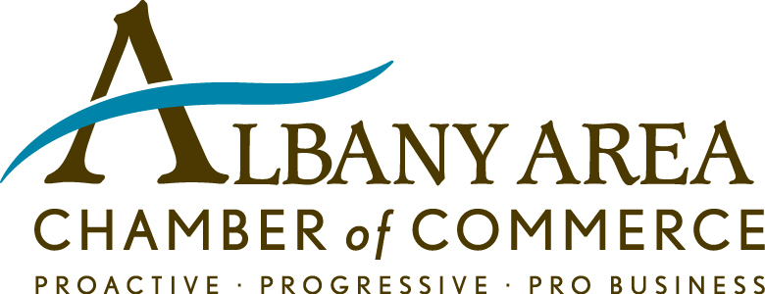

Education Division

Education Committee

+ Priority One! Volunteer/Mentor Program
Priority One! connects Chamber members who want to serve as volunteers/mentors with the Dougherty County School System and the private and parochial schools. The volunteers/mentors provide real-world guidance and support to students.

Priority One! is designed where the Chamber acts as a conductor to connect potential Chamber member volunteers/mentors with our schools (includes Dougherty County School System, private and parochial schools). Then, the coordinator at the schools is responsible for onboarding (any background checks, orientation/training), and introduction to the school.

If you are interested in being a volunteer/mentor, please e-mail Sarah Hall at shall@albanyga.com for an application form. Complete details of the Priority One! Volunteer/Mentor program, and the application form can also be downloaded at this link. Once you complete the application form, please forward to Sarah Hall.

+ Go SEE! School Visit/Tour
Go SEE! School Visit/Tour program
- Builds relationships and partners
- Provides exposure to community schools
- Creates awareness of the achievements, and needs, of community schools
- Connects business leaders with students and teachers, and creates advocates for business engagement in education

Announcements of the Go SEE! School Visit/Tour will be sent to the Chamber members as they are planned throughout the year, with instructions to RSVP.

+ 38 active committee members

If you are interested in joining the Education Committee, please send an e-mail to Chandu Kuntawala, Kuntawala_Chandrakant@bah.com

